Lecture 6: Stages of Building an LLM from Scratch

Three Stages:
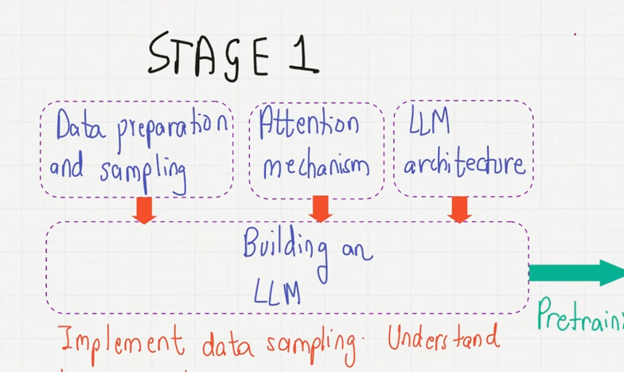
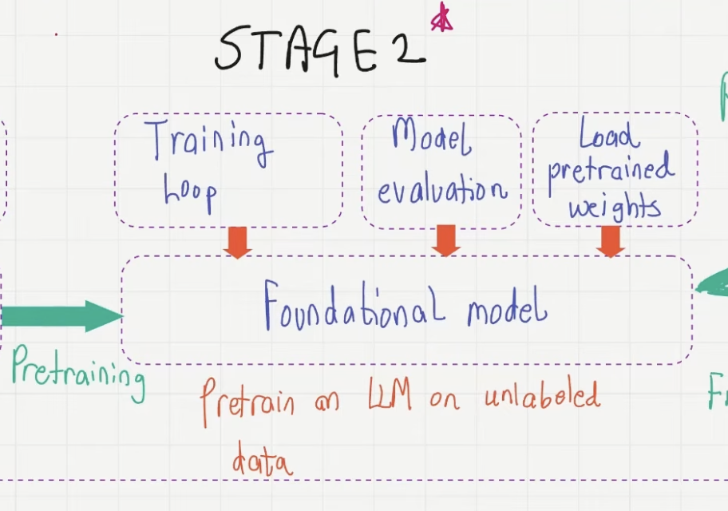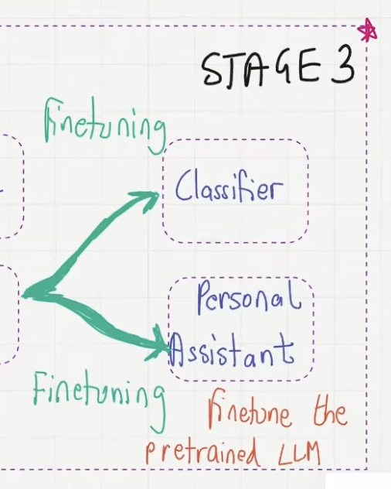

STAGE 1: Building an LLM
Building blocks:
- Data Processing and sampling: tokenization, vector embeddings, positional encoding, constructing batches of data, context length
- Attention mechanism: multi-head attention, masked multi-head attention, positional encoding
- LLM architecture

STAGE 2: Pretraining
After assembled data, training happens (pre-training). The outcome here, is to build foundational model on unlabeled data.
- Training Loop
- Model Evaluation
- Load pretrained weights

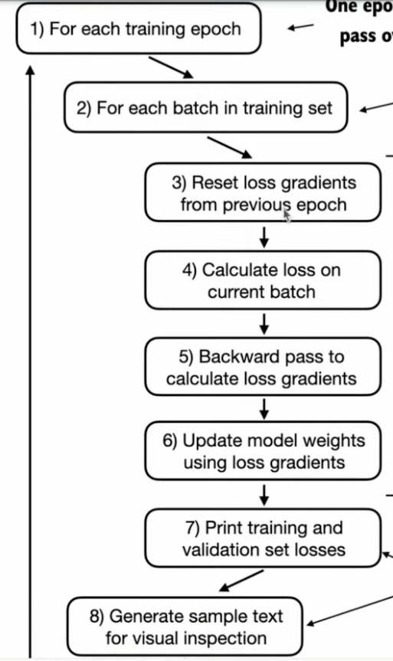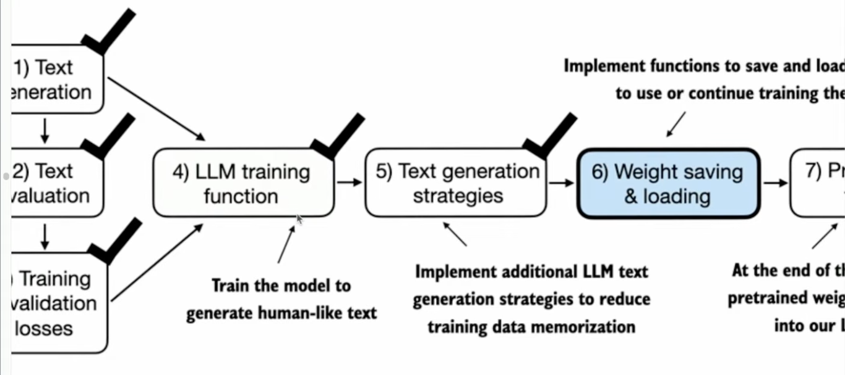

STAGE 3: Fine-tuning
If we want to build a specific applications, we need fine-tuning. Here we will do classifier (spam, no spam,), and own personal assistant, chatbot (instruction, input, output).

Many students only use stage 3 and use Langchain or Ollama and directly apply applications.

Recap
- LLMS have transformed the field of NLP. They have led to advancements in generating, understanding and translating human language. The field of NLO you need to train separate algorithm for each specific task but LLLMs are pretty generic if you train LLM for predicting next word turns out it develop emergent properties. Useful for a wide range of task and that made it predominantly used as an amazing tool in variety of fields.
- Modern LLMs are trained in 2 main steps:
  - Pretraining on unlabeled data, foundational. Model, and for this very large dataset is needed, billions of words, and it costs a lot. (Autoregressive)
  - Fine-tuning: if you want to deploy it at production level btu pretrained model is very generic and you want to provide your own specific data set and label it and further train on the refined dataset. Like airline companies, restaurants, banks, educational companies, when they deploy, they fine tune, no body applies it directly, you fine tune on specific small labeled dataset. Generally, fine tuning is needed for building production ready LLM application. It is also important to know that finetuned LLMs can outperform just pretrained LLMs on specific tasks.
- The secret sauce behind LLMs is transformer architecture, key idea is attention mechanism the main thing behind the. Transformer architecture that really makes it so powerful are these attention blocks. Use the LLM selective access to the whole input sequence when generating output one word at a time. Understanding importance words in the current sentence also previous sentence, because context is important, long rang dependencies, entire context.
- Original Transformer Architectre: encoder + decoder
- GPT: only decode, no encoder. So transformers and GPT are not the same thing
- While LLMs are only trained for predicting next word, they show emergent properties, ability to classify, translate, summarize texts.

